Project Design Phase-1 Solution Kit

|  |  |
| --- | --- |
| DATE | 10 November 2022 |
| TEAM ID | PNT2022TMID51261 |
| PROJECT NAME | Real-Time River Water Monitoring and Control System |

Farmers and people in rural areas those who live near rivers

The system is complex and hard to rectify if fault occurs. Sometimes the customer needs to take some time to under the working of the system.

An alert system to notify the people through sms and the corporation/government people to make sure the particular region in the river is safeguarded.

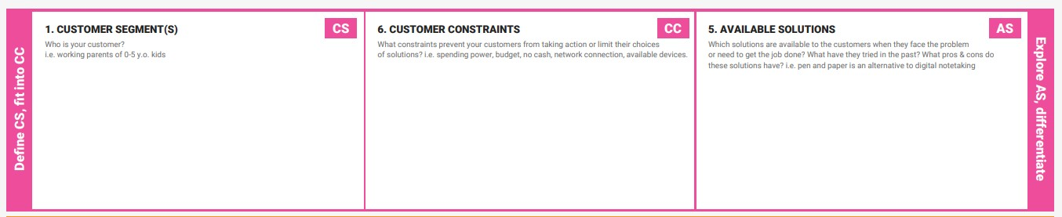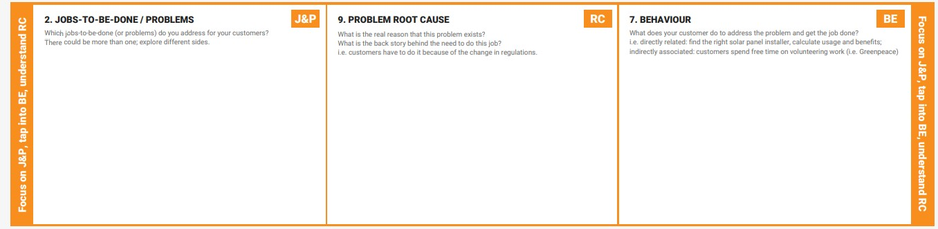The river water monitoring system checks parameters like PH level, dust particles, temperature, turbidity and sends alarm notification if the threshold value is not met.

We will be using sensors to detect the previously mentioned parameters in case if any one of them fails the whole system becomes endangered.

A customer care can be setup to address and solve the issues faced by the user.